 | GELFA ACADEMY TUTORIAL CENTRE | 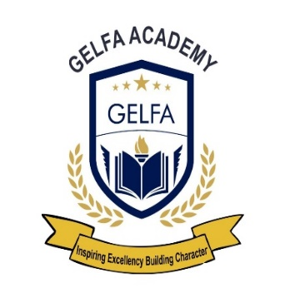
HIGH SCHOOL
Portion 381 of Farm Hekpoort 504
Mogale City Johannesburg Gauteng
1790
Telephone: 061 906 3981
Email address: admin@gelfa.co.za
______________________________________________

Date: 11 January 2026
To Whom It May Concern,

RE: TRANSFER LETTER FOR EUGENIA NDLOVU
This letter serves to confirm that Eugenia Ndlovu was a student at Gelfa Academy Tutorial Centre and has completed her Form 2 (Grade 9) level of education.
Eugenia is transferring from Gelfa Academy at the request of her parents. We wish to confirm that she leaves our institution in good standing, having concluded the 2025 academic year.
Academic & Behavioral Standing:
- Performance: Eugenia’s academic results have remained consistently above average. She has shown great aptitude across her subjects, as evidenced by her Form 2 End of Year 2025 Report (attached).
- Character: She has been an exemplary student with a positive work ethic and a respectful demeanor toward staff and fellow students.
We fully support her transition to a new learning environment for her Form 3 studies and are confident she will maintain her high standards of achievement.
Please feel free to contact the undersigned should you require any additional information or verification.
Yours Faithfully,
Mr Mubharwa
Principal Gelfa Academy

